Instructions (READ THIS FIRST):
Activity 1 (Overview): Watch Crash Course United States History numbers 1 and 2 and take notes while watching. There should be AT LEAST 5-6 bulleted points noting main ideas, key details, and terminology in each section.

Activity 2 (Native American Cultures): Watch the Tom Richey video on pre-Columbian Native cultures to fill out the graphic organizer and the map. You may need to access reliable internet sources to complete the map.

Activity 3 (Columbian Exchange): Watch the Crash Course World History video on the Columbian exchange and answer the questions. Answers should include evidence from the video and be between 3-5 sentences in length.

Activity 4 (European Colonization): Watch the Tom Richey videos on each European country’s New World colonization to fill out the graphic organizer.

Activity 5 (Middle Passage): Use the five documents on the slave trade to answer the guided questions in 2-3 complete sentences, fill out the graphic organizer, and answer the culminating question. The answer for the culminating question should be a thorough 6-8 sentence paragraph noting evidence from the documents.

Activity 6 (U.S. Maps): Fill out the following elements on the corresponding maps. Color the maps in if desired.
US Political Map: Label all states, capital cities, & date of admission of each state.
US Physical Map: Label Mountains (Appalachians, Rocky, Sierra Nevada & Coast Ranges), Lakes (Tahoe, Great Salt, Superior, Michigan, Huron, Erie & Ontario), Rivers (Mississippi, Missouri, Ohio, Tennessee, Colorado, Rio Grande, Kansas, Columbia, Sacramento, San Joaquin, Red & Platte), and Bodies of Water (Pacific, Atlantic, & Gulf of Mexico)

General Statements: All work should be handwritten. If you cannot print out these pages, answer the questions on separate pieces of paper. ALL ASSIGNMENTS MUST BE THE WORK OF THE INDIVIDUAL STUDENT SUBMITTING THE WORK! Any duplicate assignments will be issued a zero. Students are not to split to work or share their assignments with others. Students can contact me via e-mail throughout the summer if they have questions. Keep in mind, I do not check my e-mail every day so please allow time for me to respond.

Due Date Information: Assignments are due at the beginning of class on Tuesday, September 7th. The Unit 1 Test will be administered that day as well. This test covers the content from this assignment (U.S. History prior to 1607). Any assignment turned in after that date will receive a reduced grade. Not completing a summer assignment will be detrimental to a student’s 1st quarter grade.
Mr. Webster
jwebster@ccboe.com
A.P. U.S. History
Lackey high school
Summer Assignment 2022
Time Period 1 (1491 – 1607)
NAME: _____________________________________
1A: Take detailed notes while watching the corresponding video: https://www.youtube.com/watch?v=6E9WU9TGrec

The Black Legend, Native Americans, Spaniards: Crash Course US History #1
Beginning Points
Thought Bubble
Mystery Document
**Big Idea
Conclusion
1B: Take detailed notes while watching the corresponding video: https://www.youtube.com/watch?v=o69TvQqyGdg

When is Thanksgiving? Colonizing America: Crash Course US History #2
Beginning Points
Thought Bubble
Mystery Document
**Big Idea
Conclusion
2A: Native American Cultures: https://www.youtube.com/watch?v=zG_Q50JDeLo
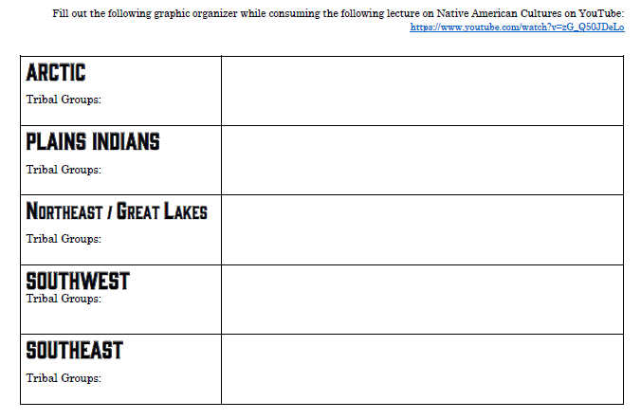
2B: Native American Cultures Map
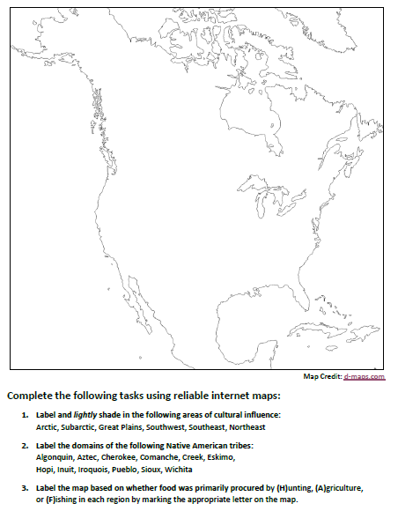
3: APUSH VIDEO: Crash Course #23: “The Columbian Exchange”
https://www.youtube.com/watch?v=HQPA5oNpfM4
Answer these questions in notes form first then rewrite in complete sentences.
1. What is the Columbian Exchange?

2. What percentage of indigenous peoples died as a result of European arrival? (this is a range) What was the main cause of these deaths?

3. Identify a few of the diseases, animals, plants, and people that (a) came to the New World from the Old, and (b) came to the Old World from the New. Briefly note the impact of these new diseases/animals/plants/people for their recipients.

4. What was the central reason why the world population doubled between 1650 and 1850?

5. Should we be grateful for the Columbian Exchange? Why or why not? (Do you agree with Crosby?)

4: Fill out the following graphic organizer by consuming the corresponding video on each European country’s colonization of the New World. Begin here: https://www.youtube.com/watch?v=EdV98rKV5gM
Spanish Colonization: https://www.youtube.com/watch?v=IhWMMEKNxdQ
French Colonization: https://www.youtube.com/watch?v=UqUSY59Kilk
Dutch Colonization: https://www.youtube.com/watch?v=rH1uGY16WJM
English Colonization: https://www.youtube.com/watch?v=ecFVogu0H2w

 | SPANISH | FRENCH | DUTCH | ENGLISH
Region(s) Colonized

Religion

Interested Parties

Economic Pursuit(s)

Settlements

Number of Colonists

Evangelism?

Relationship with Native Americans

5 (Guided Questions/Graphic Organizer/Culminating Question):
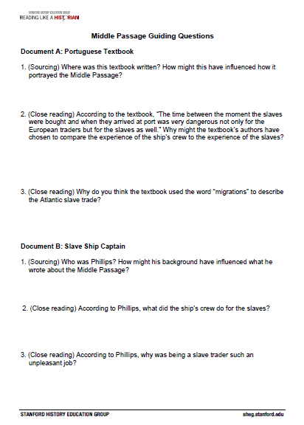
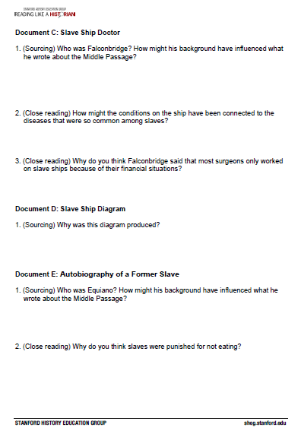
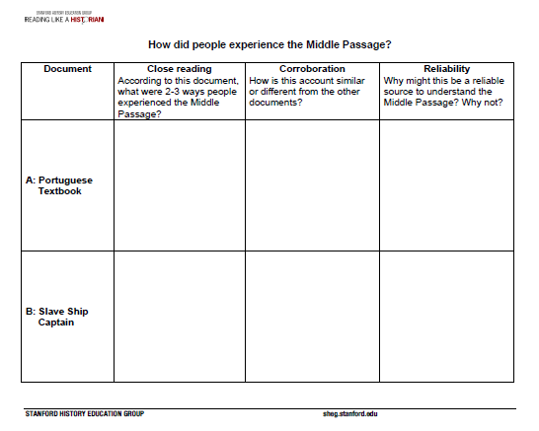
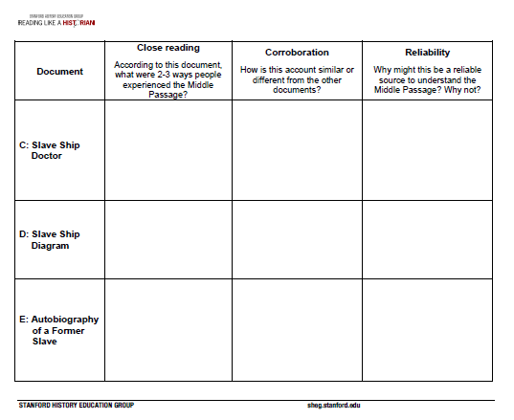
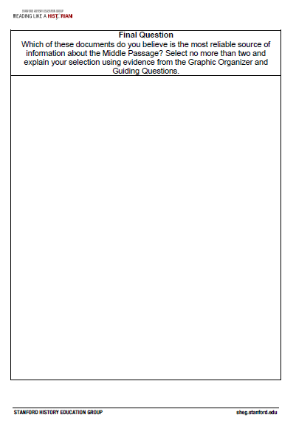
5 (Documents):

Document A: Portuguese Textbook

Portugal was one of the first European countries to engage in the African slave trade. Portuguese ships played a key role in the slave trade between Europe, Africa, and the Americas for several centuries. The following excerpt comes from a Portuguese high school textbook.

Slavery was one of the pillars of African societies. The prestige and power of the great African lords was evaluated by the number of slaves one had. The practice of slavery in Africa would facilitate the entry of Europeans into the process. To interpret the slavery trade as a unique form of colonial exploitation is to forget that it was a practice perpetuated by the natives. The slave traders operated directly with the local slave masters. Generally, the advantages to both parties were equal: the African obtained manufactured products from Europe and military help he needed to defend himself against his enemies.

The development of the slave trade became part of the process of settling the American continent. In comparison with Indian slavery, the blacks had a better physical capacity and resisted better to the climate, two important factors to justify the successive waves of slaves that left Africa towards America.

The time between the moment the slaves were bought and when they arrived at port was very dangerous not only for the European traders but for the slaves as well. Revolts and disturbances occurred frequently. Crossing the Atlantic was extremely difficult for slaves. First there was not enough room in the boats. They suffered from heat, thirst, and a lack of hygiene. Even the whites had difficulty with these things.

At the time the European states did not recognize the negative consequences of these massive migrations. On the other hand, a new diverse cultural situation originated on the American continent that resulted from the multiplicity of mixed races and cultures. Brazil became the most expressive model of the process carried out by the Portuguese as it melted Indian, white, and black in a complex mix of ethnicities and cultures.

Source: History for Grade Ten, Volume 2, published in Portugal in 1994.

Document B: Slave Ship Captain

Captain Thomas Phillips transported slaves from Africa to Barbados on the ship Hannibal in 1693. The ship left the African island of São Tomé on August 25th and arrived in Barbados on November 4th.The Royal African Company of London funded the trip. This is an excerpt from his journal about the voyage.

We spent in our passage from St. Thomas to Barbadoes two months eleven days, from the 25th of August to the 4th of November following: in which time there happened such sickening and mortality among my poor men and Negroes. Of the first we buried 14, and of the last 320, which was a great detriment to our voyage, the Royal African Company losing ten pounds by every slave that died, and the owners of the ship ten pounds ten shillings, being the freight agreed on to be paid by the charter-party for every Negro delivered alive ashore to the African Company’s agents at Barbadoes. . . .

The distemper which my men as well as the blacks mostly died of was the white flux, which was so violent and inveterate that no medicine would in the least check it, so that when any our men were seized with it, we esteemed him a dead man, as he generally proved. I cannot imagine what should cause it in them so suddenly, they being free from it till about a week after we left the island of St. Thomas. . . .

The Negroes are so incident to the small-pox that few ships that carry them escape without it, and sometimes it makes vast havoc and destruction among them. But tho’ we had 100 at a time sick of it, and that it went thro’ the ship, yet we lost not above a dozen by it. All the assistance we gave the diseased was only as much water as they desir’d to drink, and some palm-oil to anoint their sores, and they would generally recover without any other helps but what kind nature gave them.

One thing is very surprising in this distemper among the Blacks, that tho’ it immediately infects those of their own colour, yet it will never seize a white man; for I had several white men and boys aboard that had never had that distemper, and were constantly among the Blacks that were sick of it, yet none of them in the least catch’d it, tho’ it be the very same malady in its effects, as well as symptoms among the Blacks as among us in England, beginning with the pain in the head, back, shivering, vomiting, fever, etc.

But what the smallpox spar’d, the flux swept off, to our great regret, after all our pains and care to give them their messes in due order and season, keeping their lodgings as clean and sweet as possible, and enduring so much misery and stench so long among a parcel of creatures nastier than swine, and after all our expectations to be defeated by their mortality.

No gold-finders can endure so much noisome slavery as they do who carry Negroes; for those have some respite and satisfaction, but we endure twice the misery; and yet by their mortality our voyages are ruined, and we pine and fret ourselves to death, and take so much pain to so little purpose.

Source: Thomas Phillips, A Collection of Voyages and Travels, 1732.

Document C: Slave Ship Doctor

Alexander Falconbridge served as a doctor (known as the surgeon on ships) on British slave ships during the 1780s. He later wrote a book, An Account of the Slave Trade on the Coast of Africa, about his experiences. The book became popular among abolitionists and he later worked with the Anti-Slavery Society. These are excerpts from his book.

The men negroes, on being brought aboard the ship, are immediately fastened together, two and two, by hand-cuffs on their wrists, and by irons riveted on their legs. They are then sent down between the decks, and placed in an apartment partitioned off for that purpose. The women likewise are placed in a separate apartment between decks, but without being ironed. And an adjoining room, on the same deck, is besides appointed for the boys. Thus are they all placed in different apartments.

But at the same time, they are frequently stowed so close, as to admit of no other posture than lying on their sides. Neither will the height between decks, unless directly under the grating, permit them the indulgence of an erect posture; especially where there are platforms, which is generally the case. These platforms are a kind of shelf, about eight or nine feet in breadth, extending from the side of the ship towards the centre. They are placed nearly midway between the decks, at the distance of two or three feet from each deck. Upon these the negroes are stowed in the same manner as they are on the deck underneath.

In each of the apartments are placed three or four large buckets, of a conical form, being near two feet in diameter at the bottom, and only one foot at the top, and in depth about twenty-eight inches, to which, when necessary, the negroes have recourse. It often happens, that those who are placed at a distance from the buckets, in endeavoring to get to them, tumble over their companions in consequence of their being shackled. These accidents, although unavoidable, are productive of continual quarrels, in which some of them are always bruised. In this distressed situation, unable to proceed, and prevented from getting to the tubs, they desist from the attempt; and, as the necessities of nature are not to be repelled, ease themselves as they lie. This becomes a fresh source of broils and disturbances and tends to render the condition of the poor captive wretches still more uncomfortable. The nuisance arising from these circumstances is not infrequently increased by the tubs being much too small for the purpose intended, and their being usually emptied but once every day. The rule for doing this, however, varies in different ships, according to the attention paid to the health and convenience of the slaves by the captain. . . .

They are commonly fed twice a day, about eight o’clock in the morning and four in the afternoon. On most ships they are only fed with their own food once a day. Their food is served up to them in tubs, about the size of a small water bucket. They are placed around these tubs in companies of ten to each tub, out of which they feed themselves with wooden spoons. These they soon lose, and when they are not allowed others, they feed themselves with their hands. In favourable weather they are fed upon deck, but in bad weather their food is given them below. Numberless quarrels take place among them during their meals; more especially when they are put upon short allowance, which frequently happens, if the passage from the coast of Guinea to the West-India islands, proves of unusual length. In that case the weak are obliged to be content with a very scanty portion. Their allowance of water is about half a pint each at every meal. It is handed round in a bucket, and given to each negroe in a pannekin; a small utensil with a strait handle, somewhat similar to a sauce-boat. However, when the ships approach the islands with a favourable breeze, they are no longer restricted.

Upon negroes refusing to take sustenance, I have seen coals of fire, glowing hot, put on a shovel, and placed so near their lips, as to scorch and burn them. And this has been accompanied with threats, of forcing them to swallow the coals, if they any longer persisted in refusing to eat. These meals have generally had the desired effect. I have also been credibly informed, that a certain captain in the slave trade, poured melted lead on such of the negroes as obstinately refused their food. . . .

The hardships and inconveniences suffered by the negroes during the passage, are scarcely to be enumerated or conceived. They are far more violently affected by the sea-sickness, than the Europeans. It frequently terminates in death, especially among the women. But the exclusion of the fresh air is among the least tolerable. . . .

During the voyages I made, I was frequently a witness to the fatal effects of this exclusion of the fresh air. I will give one instance, as it serves to convey some idea, though a very faint one, of the sufferings of those unhappy beings whom we wantonly drag from the native country, and doom to perpetual labour and captivity. Some wet and blowing weather having occasioned the portholes to be shut, and the grating to be covered, fluxes and fevers among the negroes ensued. While they were in this situation, I frequently went down among them, till at length their apartments became so extremely hot, as to be only sufferable for a very short time. But the excessive heat was not the only thing that rendered their situation intolerable. The deck, that is, the floor of their rooms, was so covered with the blood and mucus which had proceeded from them in consequence of the flux, that it resembled a slaughter-house. It is not in the power of the human imagination to picture to itself a situation more dreadful or disgusting. . . .

The surgeons employed in the Guinea trade, are generally driven to engage in so disagreeable an employ by the confined state of their finances.

Source: Alexander Falconbridge, An Account of the Slave Trade on the Coast of Africa, 1788.

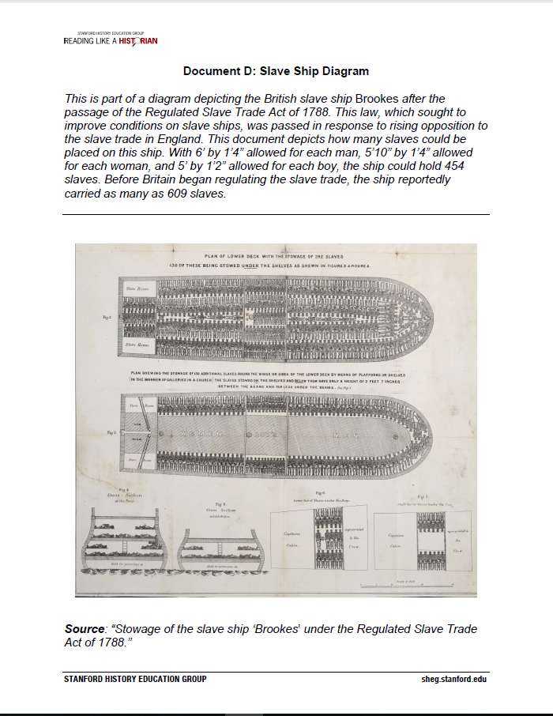
Document E: Autobiography of a Former Slave

Olaudah Equiano was born in West Africa. As a young boy, he was kidnapped by an African tribe and sold to European slave traders, who took him to Virginia. He eventually purchased his freedom and moved to England, where he became active in the abolition movement. He later wrote an autobiography describing his experiences as a slave. Recently, a historian located evidence indicating that Equiano was actually born in South Carolina. However, other historians maintain that there is strong evidence corroborating Equiano’s account. Moreover, this is one of the only accounts of the Middle passage from the perspective of a slave. These are excerpts from Equiano’s autobiography.

Soon after this the blacks who brought me onboard went off, and left me abandoned to despair. I now saw myself deprived of all chance of returning to my native country, or even the least glimpse of hope of gaining the shore, which I now considered as friendly; and I even wished for my former slavery in preference to my present situation, which was filled with horrors of every kind, still heightened by my ignorance of what I was to undergo. I was not long suffered to indulge my grief; I was soon put down under the decks, and there I received such a salutation in my nostrils as I had never experienced in my life: so that, with the loathsomeness of the stench, and crying together, I became so sick and low that I was not able to eat, nor had I the least desire to taste any thing. I now wished for the last friend, death, to relieve me; but soon, to my grief, two of the white men offered me eatables; and, on my refusing to eat, one of them held me fast by the hands, and laid me across I think the windlass, and tied my feet, while the other flogged me severely. I had never experienced any thing of this kind before; and although, not being used to the water, I naturally feared that element the first time I saw it, yet nevertheless, could I have got over the nettings, I would have jumped over the side, but I could not; and, besides, the crew used to watch us very closely who were not chained down to the decks, lest we should leap into the water: and I have seen some of these poor African prisoners most severely cut for attempting to do so, and hourly whipped for not eating. This indeed was often the case with myself. The crew used to watch us very closely who were not chained down to the decks, lest we should leap into the water: and I have seen some of these poor African prisoners most severely cut for attempting to do so, and hourly whipped for not eating. This indeed was often the case with myself . . .

In a little time after, amongst the poor chained men, I found some of my own nation, which in a small degree gave ease to my mind. I inquired of these what was to be done with us; they gave me to understand we were to be carried to these white people’s country to work for them. I then was a little revived, and thought, if it were no worse than working, my situation was not so desperate: but still I feared I should be put to death, the white people looked and acted, as I thought, in so savage a manner; for I had never seen among any people such instances of brutal cruelty; and this not only shown towards us blacks, but also to some of the whites themselves. One white man in particular I saw, when we were permitted to be on deck, flogged so unmercifully with a large rope near the foremast, that he died in consequence of it; and they tossed him over the side as they would have done a brute. This made me fear these people the more.

Source: Olaudah Equiano, The Interesting Narrative of the Life of Olaudah Equiano, Or Gustavus Vassa, the African, 1789.

6A: Political Map of the United States: Label all states, capital cities, & date of admission of each state
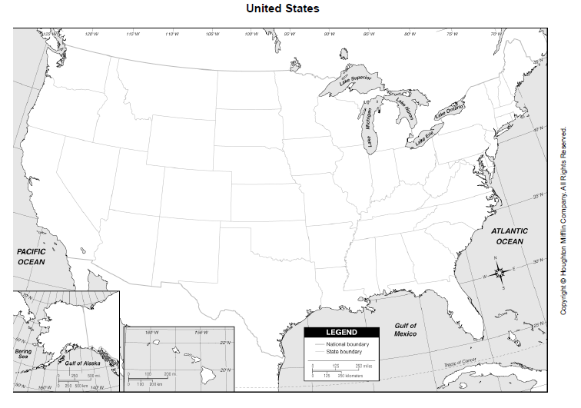
6B: Physical Map of the United States: Label Mountains (Appalachians, Rocky, Sierra Nevada & Coast Ranges), Lakes (Tahoe, Great Salt, Superior, Michigan, Huron, Erie & Ontario), Rivers (Mississippi, Missouri, Ohio, Tennessee, Colorado, Rio Grande, Kansas, Columbia, Sacramento, San Joaquin, Red & Platte), and Bodies of Water (Pacific, Atlantic, & Gulf of Mexico)
